9-PIN NO-TAP SUPERBOWL TOURNAMENT

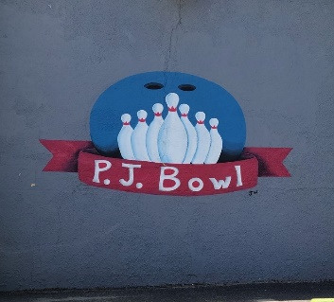
@ PJ BOWL

Sunday, February 7th, 2021 - 10 a.m.

Check-in begins at 9 a.m.

On-site entries will close at 9:30 a.m.

You must be in line before 9:30 to enter.

Pre-Registration is HIGHLY recommended.

OIL PATTERN: STANDARD HOUSE SHOT
TOURNAMENT RULES
Pre-Paid Entry Fee is $30.00: Friends and family only @PayPal - paypal.me/pjbowlnotap
Walk-in Fee is 35.00.
This is a SINGLES Event. Open to all adult bowlers.
Bowl 3 games of 9-pin no-tap. Knocking down 9 pins on the first ball is a strike.
Handicap is based on 80% of 230.
Average Rule:
- We will use highest Standard Composite Average from 2019-2020 or 2018-2019, whichever is higher, or
- If no average has been verified per USBC sanctioned league on bowl.com, you will bowl scratch 230.
- All reporting of bowler averages is the sole responsibility of the bowler. Failure to give the correct average or give us your USBC card number may result in an average adjustment or possible disqualification.
Games can exceed 300 with handicap, and the maximum series can exceed 900 with handicap.
Fee breakdown: Lineage = $12.00, Prize Fund = $15.00, Expenses = $3.00
Prize fund will be paid $400 for first, $200 for second, $100 for third based on 48 entries, otherwise will be paid at a 1 in 16 ratio, which means at least 1 place will be paid for every 16 paid entries. Money allocated to the prize fund will be returned 100%.
You can also sign up online, and Results will be listed at Tournamentbowl.com

THIS IS A USBC CERTIFIED TOURNAMENT, ALL USBC RULES APPLY.
Final rule decisions are solely at the discretion of the Tournament Director.

ENTRY FORM
Full Name: ________________________________________________________________________
Address: _________________________________________________________________________
City: State: ZIP: ____________________________________________________________________
Phone: ______________________________ E-mail:_______________________________________
Entering Average: __________ USBC Number:________________________________
(Failure to give the correct average or USBC card number may result in an average adjustment or
possible disqualification.)
Forms may be mailed to:
Jason Csencsits
210 route 209
Port Jervis NY 12771

OR
E-MAIL: pjbowlnotap@gmail.com. Please retain copies for your records.
ALL ENTRIES MUST BE RECEIVED BY January 30th, 2021 FOR PRE-REGISTRATION.
Entries will be accepted at the event until 9:30 am if space is available.

